qsite Gold coast

professional learning Term 2, 2021

Year 7 – 10 Digital and Design Technologies Integration Teachmeet

Location

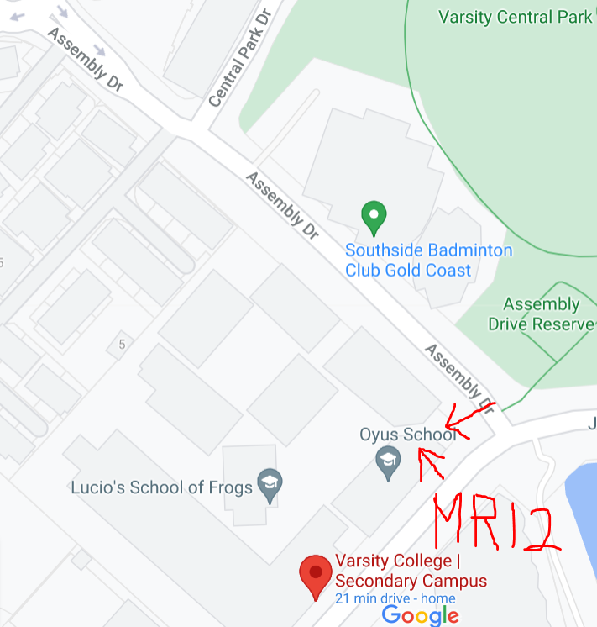
Teachers can park in the angled parking on Assembly Drive or on Central Park Drive next to the field.

Park on the street between the oval and the school.
The arrows show where to enter the school and where MR12 is.
As soon as you enter the school you go up the stairs in front of you, and when you get to the top you will see MR12 on the right.
There is no need to book but if you have any inquiries you are welcome to email Jenni or Michele at QSITE GC Chapter: goldcoast@qsite.edu.au

